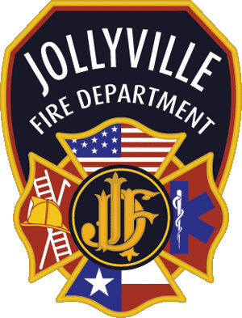

Jollyville Fire Department

“Desire to Serve, Courage to Act, Ability to Perform”

9218 Anderson Mill Road, Austin, TX 78729 (512) 258-1038

FIRE INSPECTOR FEES

Plan Reviews:
Site Plan with comments per code | $150.00
Building Plans, with comments per code | $150.00 per floor
Sprinkler Inspections, add to Site/Building fee | $150.00 per floor
Flow Test | $300.00
Sprinkler Plans | $150.00 per floor
Fire Alarm Plans | $100.00 per floor
Subdivision Plans | $100.00
Inspections:
Certificate of Occupancy | $50.00 per floor
Daycare, Foster Care, etc. | $50.00
Health Care, Assisted Living, first floor per building | $50.00 per floor
Fire Alarm Test | $100.00 per floor
Vent Hoods | $50.00 per hood
On-Site Inspector:
First Inspection $75 per hour
Re-Inspection $150 per hour
Non-Compliance Inspection(s) $300 per hour

Inspection fees are all based per site visit

ANY INSPECTIONS DONE BEFORE OR AFTER BUSINESS HOURS
WILL BE DOUBLE PRICE
OFFICE HOURS 8a-5p

